***Dt : 27/9/2022***

***\*imp***

***Multiple Inheritance Models using Interfaces:***

***Model-1 : Extracting the features from more than one interface into***

***a Class.***

***(Class implementing from more than one interfaces)***

***Diagram:***

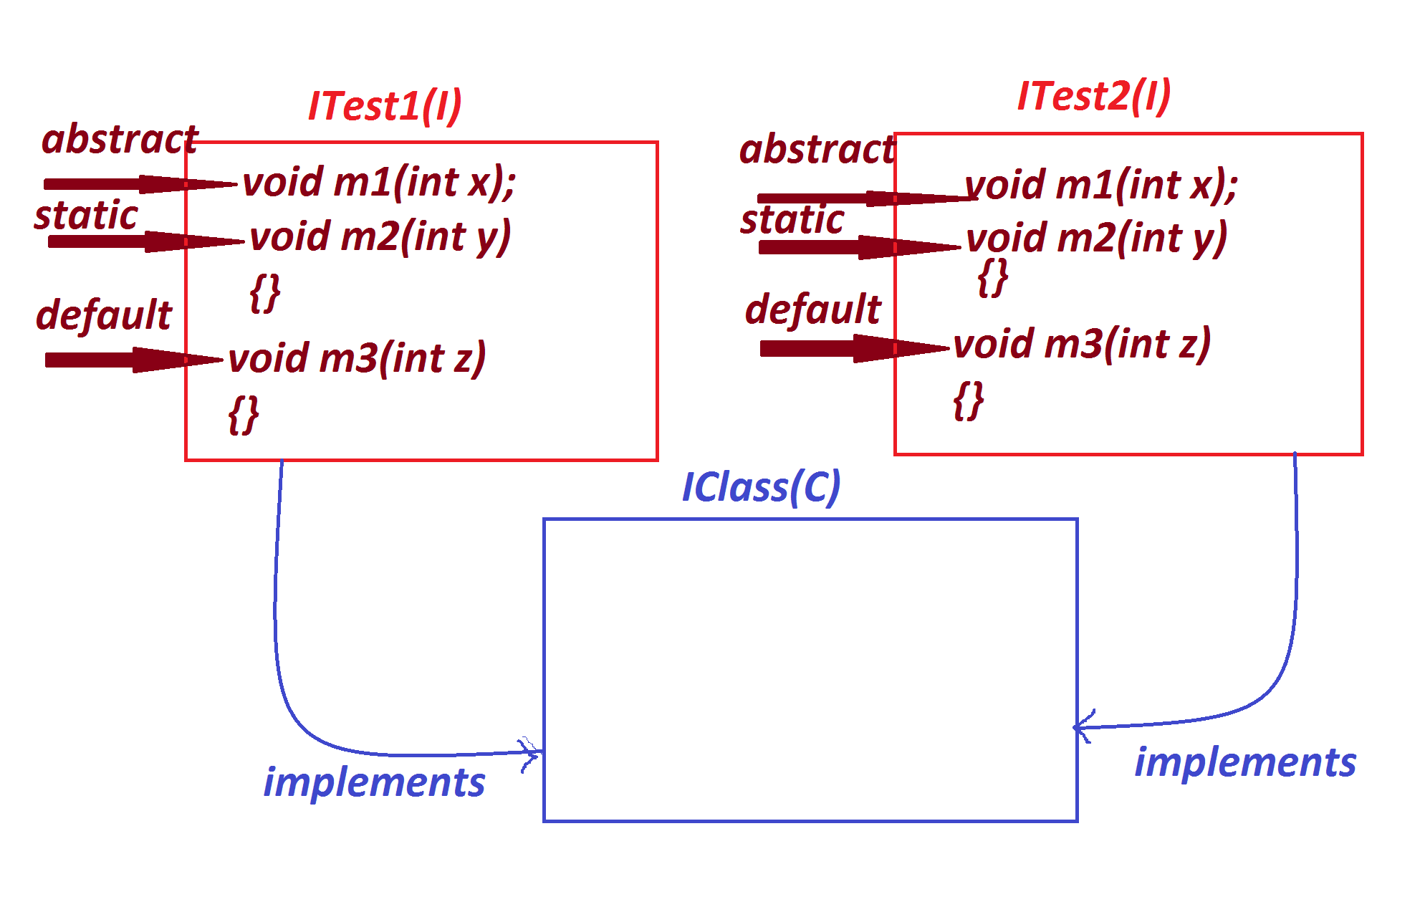

***Ex:***

***ITest1.java***

***package test;***

***public interface ITest1 {***

***public abstract void m1(int x);***

***public static void m2(int y) {***

***System.out.println("===ITest1 m2(y)===");***

***System.out.println("The value y:"+y);***

***}***

***public default void m3(int z) {***

***System.out.println("===ITest1 m3(z)====");***

***System.out.println("The value z:"+z);***

***}***

***}***

***ITest2.java***

***package test;***

***public interface ITest2 {***

***public abstract void m1(int x);***

***public static void m2(int y) {***

***System.out.println("===ITest2 m2(y)===");***

***System.out.println("The value y:"+y);***

***}***

***public default void m33(int z) {***

***System.out.println("===ITest1 m33(z)====");***

***System.out.println("The value z:"+z);***

***}***

***}***

***IClass.java***

***package test;***

***public class IClass implements ITest1,ITest2{***

***public void m1(int x) {***

***System.out.println("====m1(x)====");***

***System.out.println("The value x:"+x);***

***}***

***}***

***DemoInterface6.java(MainClass)***

***package maccess;***

***import test.*;***

***public class DemoInterface6 {***

***public static void main(String[] args) {***

***IClass ob = new IClass();***

***ob.m1(123);***

***ITest1.m2(124);***

***ITest2.m2(125);***

***ob.m3(126);***

***ob.m33(127);***

***}***

***}***

***o/p:***

***====m1(x)====***

***The value x:123***

***===ITest1 m2(y)===***

***The value y:124***

***===ITest2 m2(y)===***

***The value y:125***

***===ITest1 m3(z)====***

***The value z:126***

***===ITest1 m33(z)====***

***The value z:127***

***-----------------------------------------------------------------***

***Model-2 : Extracting the features from one class and any number of***

***interfaces into a class.***

***(Class extending from one class and implementing from any number of***

***Interfaces)***

***Diagram:***

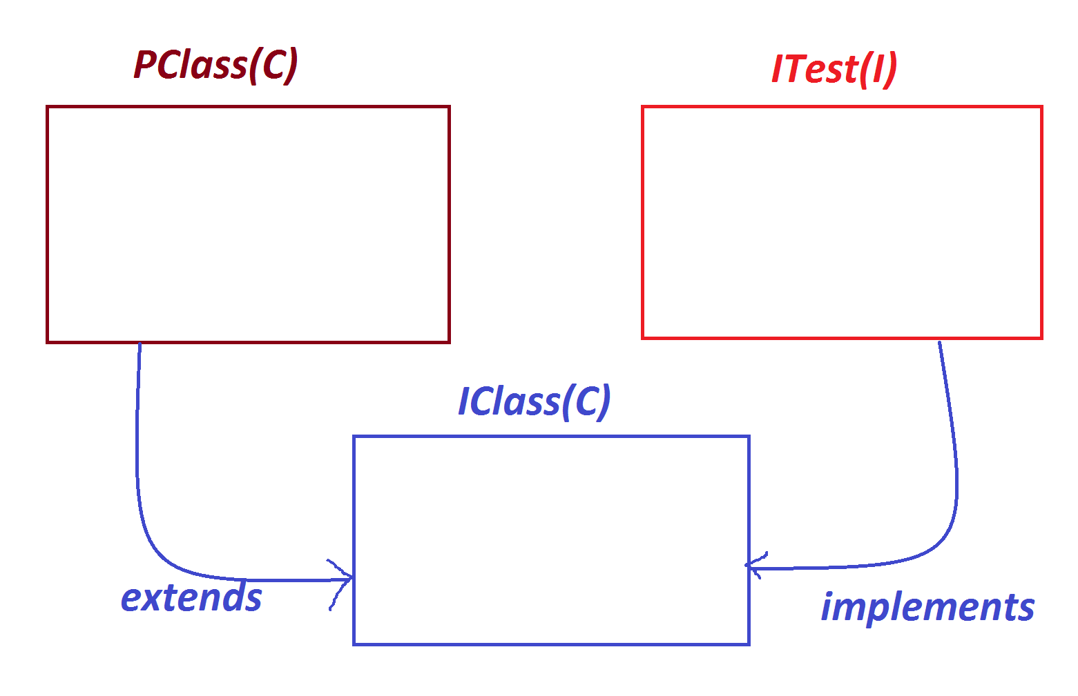

***Ex:***

***PClass.java***

***package test;***

***public class PClass {***

***public void m1(int x) {***

***System.out.println("===PClass m1(x)===");***

***System.out.println("The value x:"+x);***

***}***

***}***

***ITest.java***

***package test;***

***public interface ITest {***

***public abstract void m2(int y);***

***}***

***IClass.java***

***package test;***

***public class IClass extends PClass implements ITest{***

***public void m2(int y) {***

***System.out.println("====m2(y)====");***

***System.out.println("The value y:"+y);***

***}***

***}***

***DemoInterface7.java(MainClass)***

***package maccess;***

***import test.*;***

***public class DemoInterface7 {***

***public static void main(String[] args) {***

***IClass ob = new IClass();***

***ob.m1(12);***

***ob.m2(13);***

***}***

***}***

***o/p:***

***===PClass m1(x)===***

***The value x:12***

***====m2(y)====***

***The value y:13***

***-----------------------------------------------------------***

***Model-3 : Extracting the features from More than one interface into***

***a interface.***

***(Interface extending from more than one interface)***

***Diagram:***

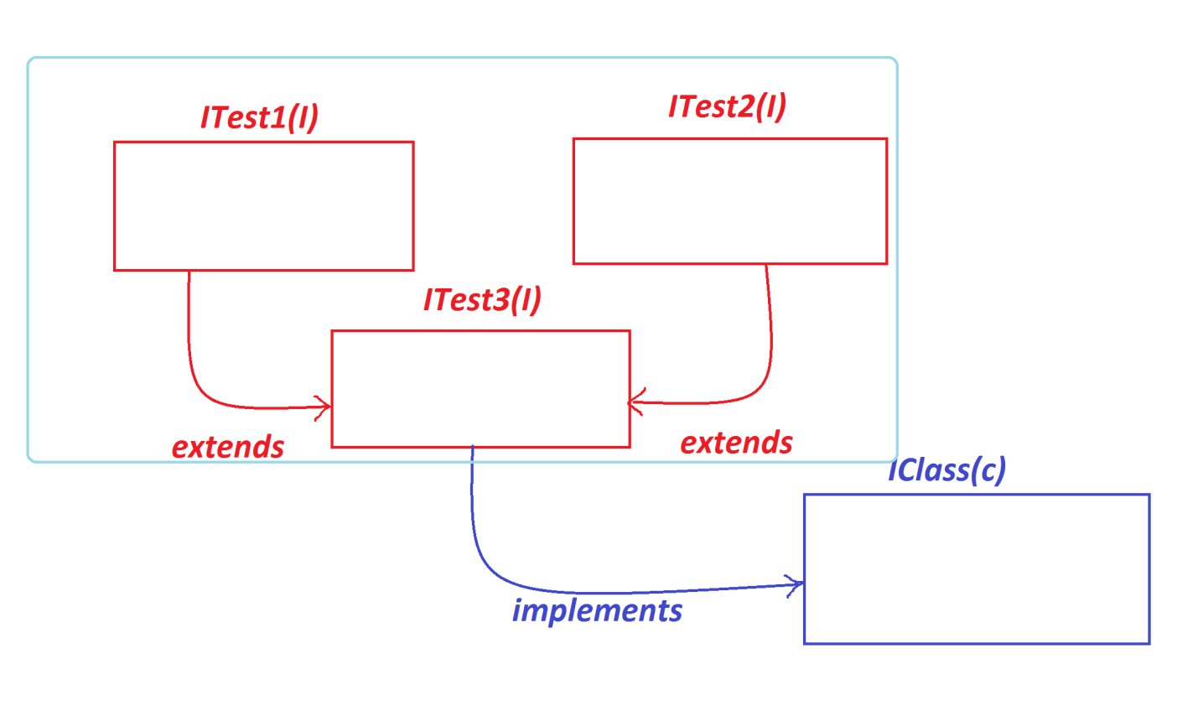

***Ex:***

***ITest1.java***

***package test;***

***public interface ITest1 {***

***public abstract void m1(int x);***

***}***

***ITest2.java***

***package test;***

***public interface ITest2 {***

***public abstract void m2(int y);***

***}***

***ITest3.java***

***package test;***

***public interface ITest3 extends ITest1,ITest2{***

***public abstract void m3(int z);***

***}***

***IClass.java***

***package test;***

***public class IClass implements ITest3{***

***public void m1(int x) {***

***System.out.println("x:"+x);***

***}***

***public void m2(int y) {***

***System.out.println("y:"+y);***

***}***

***public void m3(int z) {***

***System.out.println("z:"+z);***

***}***

***}***

***DemoInterface8.java(MainClass)***

***package maccess;***

***import test.*;***

***public class DemoInterface8 {***

***public static void main(String[] args) {***

***IClass ob = new IClass();***

***ob.m1(11);***

***ob.m2(12);***

***ob.m3(13);***

***}***

***}***

***o/p:***

***x:11***

***y:12***

***z:13***

***=========================================================***

***Assignment:***

***Construct the application using the following Layout:***

***step-1 : read pinNo***

***=>pinNo must be in 1111 or 2222 or 3333,else invalid pinNo***

***=>If pinNo entered wrongly for three times display the msg***

***as "Transaction blocked"***

***step-2 : If the pinNo is verified successfully,then show the***

***following options:***

***1.WithDraw***

***2.Deposit***

***1.WithDraw:***

***=>Enter the amt***

***=>The amt must be greater than zero and multiples of 100,***

***else "Invalid amt"***

***=>If the amt is validated successfully,then create object for***

***WithDraw class and pass amt as parameter to process() method***

***and perform transaction.(Perform transaction when amt is less***

***than balance)***

***2.Deposit:***

***=>Enter the amt***

***=>The amt must be greater than zero and multiples of 100,***

***else "Invalid amt"***

***=>If the amt is validated successfully,then create object for***

***Deposit class and pass amt as parameter to process() method***

***and perform transaction.***

***===============================================================***